**Name: E W V Pesara**

**ID: 26708**

**SE 102.3 – Web Based Application Development**

**Tutorial**

1. Write down the HTML codes required to create the following form

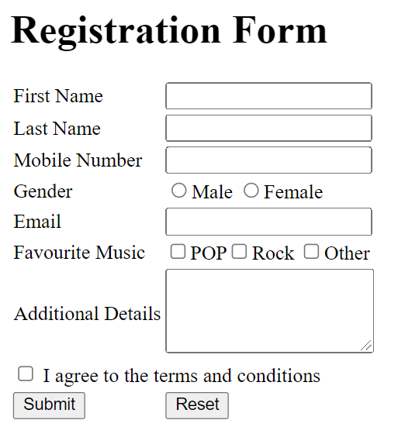

<html>

<head>

< <link href="tut.css" rel="stylesheet">

</head>

<body>

<form>

<div >

<h1>Registration Form</h1>

<br><br>

<label for="fname">First Name</label>

&nbsp;&nbsp;&nbsp; &nbsp;&nbsp;&nbsp;<input type="text" id ="fname" name="fname" placeholder="Enter your Name">

<br><br>

<label for="lname">Last Name</label>

&nbsp;&nbsp;&nbsp; &nbsp;&nbsp;&nbsp; <input type="text" id="lname" name="lname" placeholder="Enter your name">

<br><br>

<label for="mobilenumber">Mobile Number</label>

<input type="trl" id="phone" name="phone">

<br><br>

<label for="gender" >Gender</label>

&nbsp;&nbsp;&nbsp; &nbsp;&nbsp;&nbsp;&nbsp;&nbsp;&nbsp; &nbsp;&nbsp;&nbsp;

<input type="radio" >

<label>Male</label>

<input type="radio">

<label>Female</label>

<br><br>

<label>Email</label> &nbsp;&nbsp;&nbsp; &nbsp;&nbsp;&nbsp;&nbsp;&nbsp;&nbsp;&nbsp;&nbsp;&nbsp;&nbsp;&nbsp;

<input type="text">

<br><br>

<label for="text">Favourite Music</label>

<input type="checkbox">POP

<input type="checkbox">Rock

<input type="checkbox">Other

<br><br>

<label>Additional Details</label>

<textarea></textarea>

<br><br>

<input type="checkbox">I agree to terms and conditions

<br><br>

<input type="submit">

<input type="reset">

</div>

</body>

</html>C

<html>

<html>

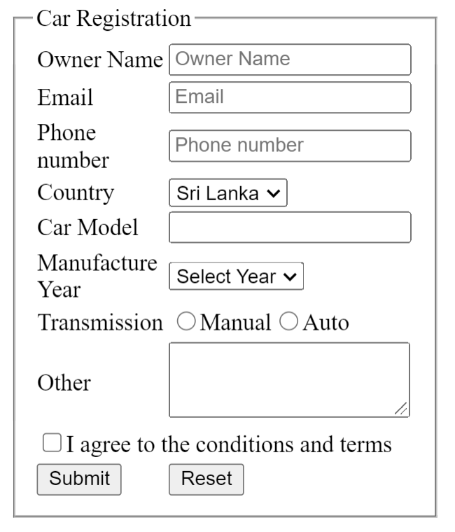

<html>

<body>

<fieldset>

<legend>Car Registration</legend>

<label>Owner Name </label>

<input type="text" placeholder="Owner Name" required>

<br><br>

<label>Email </label>&nbsp;&nbsp;&nbsp;&nbsp;&nbsp;&nbsp;&nbsp;&nbsp;&nbsp;&nbsp;&nbsp;

<input type="text" placeholder="Email" required>

<br><br>

<label>Phone<br>number</label>&nbsp;&nbsp;&nbsp;&nbsp;&nbsp;&nbsp;&nbsp;&nbsp;&nbsp;&nbsp;

<input type="tel" placeholder="Phone number" required>

<br><br>

<label for="country">Country</label>&nbsp;&nbsp;&nbsp;&nbsp;&nbsp;&nbsp;&nbsp;&nbsp;&nbsp;&nbsp;

<select name="country" id="country">

<option value="sri lanka">Sri Lanka</option>

<option value="India">India</option>

<option value="Japan">Japan</option>

</select>

<br><br>

<label>Car model</label>&nbsp;&nbsp;&nbsp;&nbsp;&nbsp;

<input type="text" required>

<br><br>

<label>Manufacture Year</label>&nbsp;&nbsp;&nbsp;&nbsp;&nbsp;&nbsp;&nbsp;&nbsp;&nbsp;&nbsp;

<select name="year" id="year">

<option>Select Year</option>

<option value="2015">2015</option>

<option value="2016">2016</option>

<option value="2017">2017</option>

<option value="2018">2018</option>

<option value="2019">2019</option>

<option value="2020">2020</option>

<option value="2021">2021</option>

</select>

<br><br>

<label>Transmission</label>&nbsp;&nbsp;&nbsp;&nbsp;&nbsp;&nbsp;&nbsp;&nbsp;&nbsp;&nbsp;

<input type="radio" name="btn" required> Manual

<input type="radio" name="btn" required>Auto

<br><br>

<label>Other</label>&nbsp;&nbsp;&nbsp;&nbsp;&nbsp;&nbsp;&nbsp;&nbsp;&nbsp;&nbsp;&nbsp;&nbsp;&nbsp;&nbsp;&nbsp;&nbsp;&nbsp;&nbsp;&nbsp;&nbsp;<textarea ></textarea>

<br><br>

<input type="checkbox">I agree to the conditions and terms

<br><br>

<input type="submit">&nbsp;&nbsp;&nbsp;&nbsp;&nbsp;&nbsp;&nbsp;&nbsp;&nbsp;&nbsp;&nbsp;&nbsp;&nbsp;&nbsp;&nbsp;&nbsp;&nbsp;&nbsp;

<input type="reset">

</fieldset>

</body>

<html>